**LAB TASK #02**

***NAME :MUHAMMAD HASSAM KHAN***

***S.ID:11141***

**QUESTION #01**

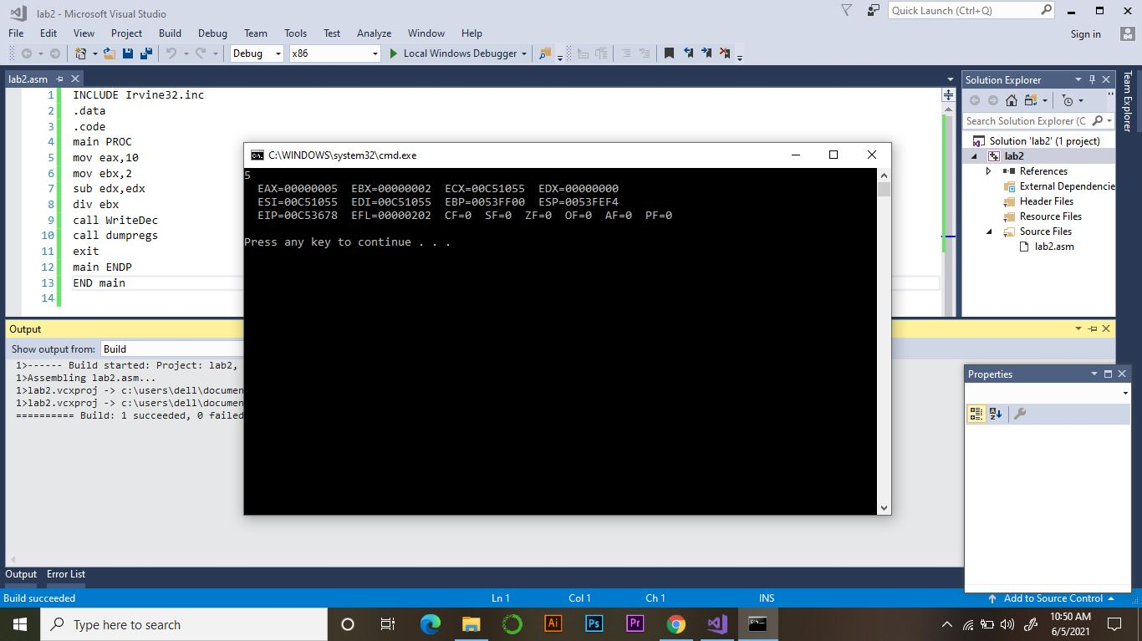

**QUESTION #02**

**(PART :A)**

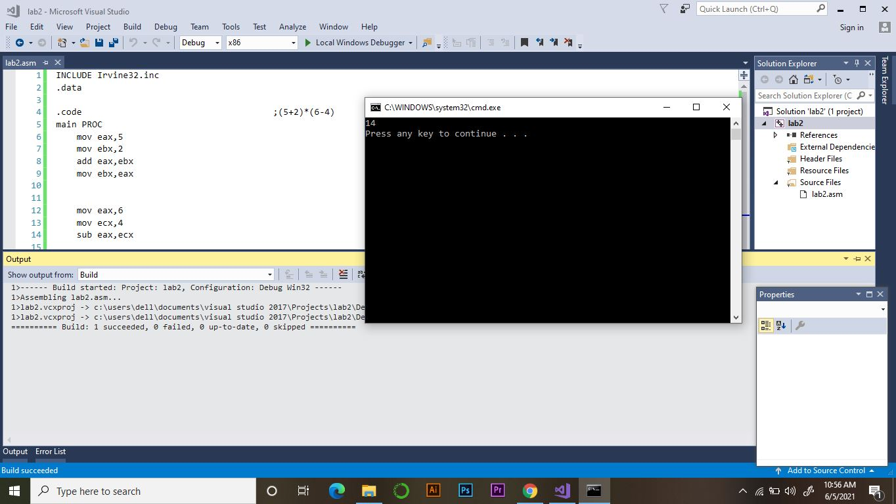

**(PART :B)**

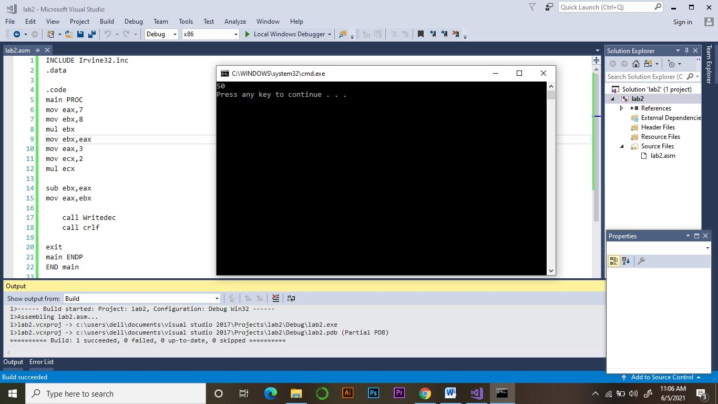

**(PART :C)**

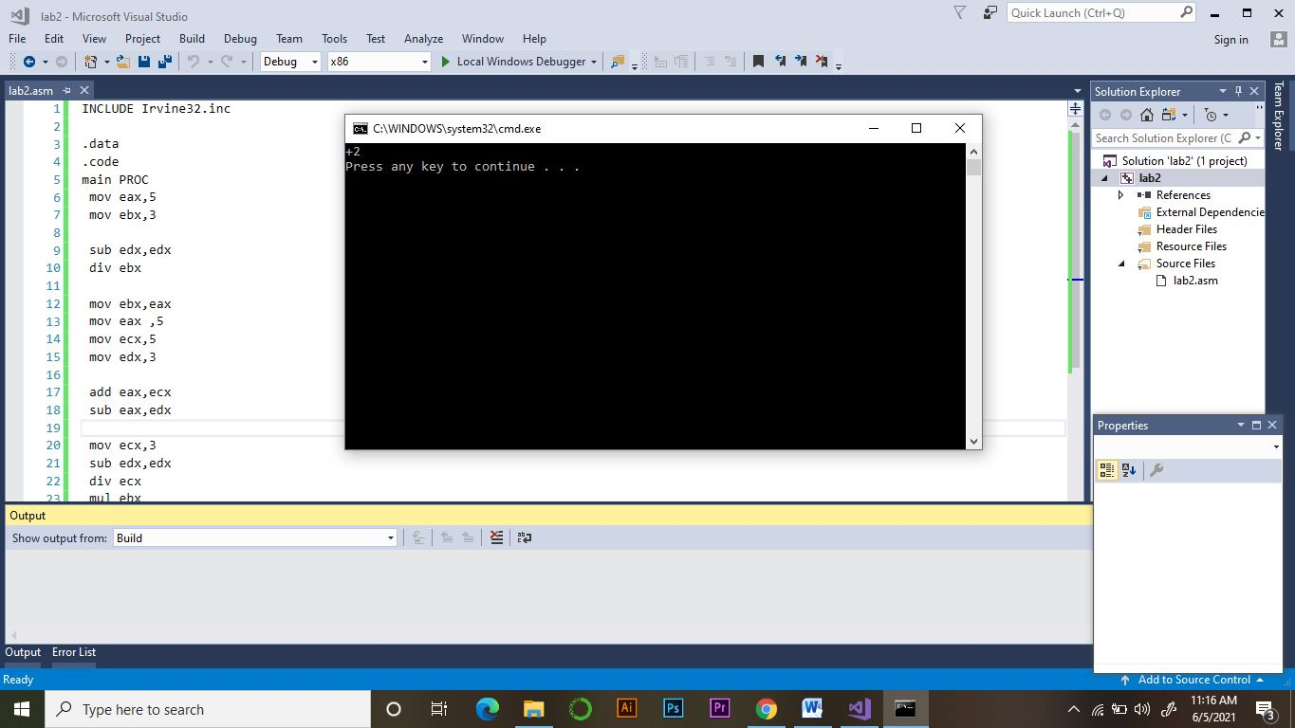

**(PART :D)**

